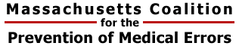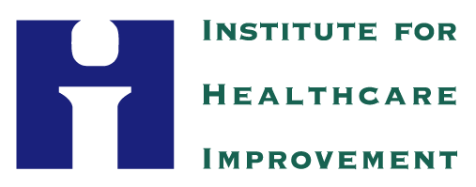

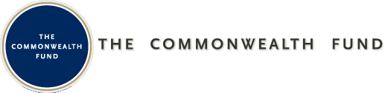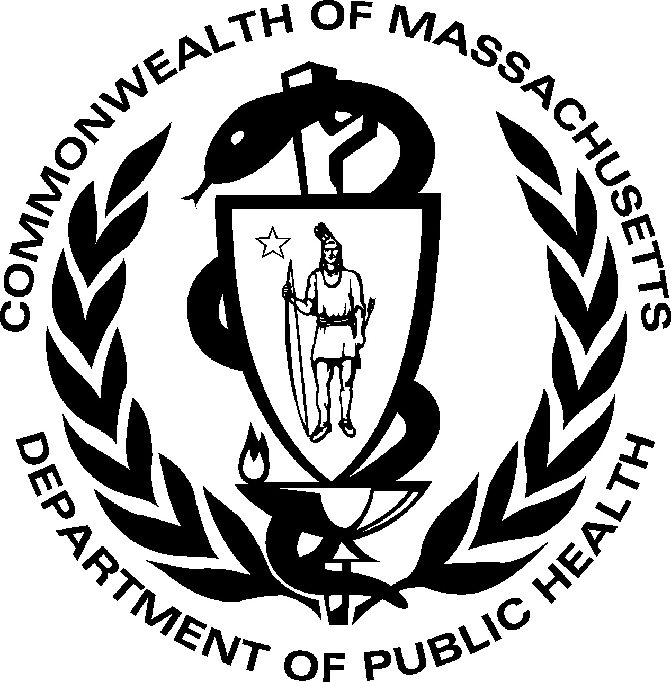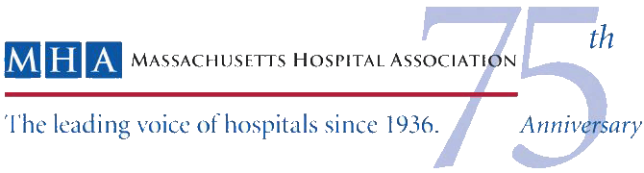

Massachusetts STAAR Learning Session
October 11-12, 2011

Working Across the Continuum to Drive for Results!
Learner Objectives
- Learn about work underway by peers in the four key changes for improving care transitions
- Engage a cross continuum team with active participation by all
- Share promising work with peers and obtain input and new ideas for achieving results
- Formulate a solid plan for accelerating your work
- Strengthen connections with peers
Day 1 – Tuesday, Oct 11
8:30-9:00AM | Welcome and Set the Stage  Presenters: Madeleine Biondolillo, Paula Griswold, Pat Noga | Grand Ballroom
9:00-9:45AM | Our Collaborative Progress and Working Across the Continuum  Presenters: Patricia Rutherford and Rebecca Steinfield | Grand Ballroom
9:45-10:45AM | STAAR Cross-Continuum Team Presentations  Presenting Teams: Baystate Medical Center and Saints Medical Center | Grand Ballroom
10:45-11:00AM | Break and Transition
11:00AM-12:15PM | Ring of Knowledge Sessions  These are interactive breakout sessions in which each team will have time to share: 1) what they are most proud of and 2) what they need help with - in the context of efforts to execute on the four key changes. The goal is to share good ideas, identify challenges, and get input from peers on how to accelerate improvement. | See Posted Room Assignments
12:15-1:15PM | Networking Lunch | In Breakout Rooms
1:15-2:30PM | Breakouts: Promising Strategies for Successful Execution: What we are learning about “what to do” and “how to do it”.
 | Breakout A: Early Assessment of Post-Hospital Needs: What can we do to better predict patients’ home going needs and help them prepare for a safe transition?  Presenting Teams: Massachusetts General Hospital, Sturdy Memorial Hospital  Facilitators: Pat Rutherford, Kate Bones | Grand North
 | Breakout B: Health Literacy and Effective Teaching: What are the most powerful tools and strategies for redesigning and executing patient-centered teaching?  Presenting Teams: Northeast Hospital Corporation, Beth Israel Deaconess Medical Center  Facilitators: Gail Nielsen, Marian Birhle-Johnson | Grand Centre
 | Breakout C: Engaging Front-Line Staff (in any setting) and Your Cross Continuum Team  Presenting Teams: South Shore Hospital  Facilitators: Peg Bradke, Rebecca Steinfield | Grand South
2:30-2:45PM | Break and Transition
2:45-4:00PM | Breakouts: Promising Strategies for Successful Execution: What we are learning about “what to do” and “how to do it”.
 | Breakout A: Ensuring Post-Hospital Care Follow-up: How do we effectively and efficiently act on our assessment of post-discharge needs and collaborate with patients, their families, and the community to transition patients home safely?  Presenting Teams: St. Anne’s Hospital, MetroWest Medical Center  Facilitators: Peg Bradke, Kate Bones | Grand North
 | Breakout B: Providing Real-time Handover Communication: What information do patient, families, and community providers need to know about their hospital stay and how can we reliably share it?  Presenting Teams: Cape Cod Hospital, Hallmark Health System  Facilitators: Gail Nielsen, Marian Bihrle-Johnson | Grand South
 | Breakout C: Engaging Patients and Families: Learning to work with patients and families as true partners in their own care.  Presenters: Janice Foust, Richard Elliott, Lindy Alves  Facilitators: Paula Griswold, Rebecca Steinfield | Grand Centre
4:00-4:15PM | Transition
4:15-5:00PM | Driving for Results  Time for cross-continuum teams to come together to share what they learned throughout the day and identify ideas to test upon returning home. | Grand Ballroom
Day 2 – Wednesday, Oct 12
8:30-9:45AM | Ring of Knowledge – part 2 (cont’d from previous day) |  | See Posted Room Assignments
9:45-10:00AM | Transition to Plenary
10:00-11:00AM | Accelerating Improvement  Presenter: Rebecca Steinfield |  | Grand Ballroom
11:00-11:15AM | Break
11:15AM-12:00PM | Partnering with Pharmacy: A panel discussion on pharmacy interventions to reduce readmissions  Panelists: Saad Dinno, Acton Pharmacy; Timothy Fensky, Sullivan’s Pharmacy  Moderator: Paula Griswold |  | Grand Ballroom
12:00-1:00PM | Networking Lunch
1:00-2:15PM | Breakouts by Care Setting
 | Breakout A: Creating an Ideal Transition to Home by Working with Office Practices, Home Health, and Community Agencies  Facilitators: Gail Nielsen, Pat Kelleher, Helen Siegel, Amy MacNulty |  | Grand North and Centre
 | Breakout B: Completing the Transition to Skilled Nursing, Acute Rehabilitation, and Long Term Care Facilities  Facilitators: Laurie Herndon and Kate Bones |  | Grand South
2:15-2:30PM | Transition to Breakouts
2:30-3:30PM | Special Topic Breakouts
 | Breakout A: Using the INTERACT Tools to Improve Nursing Home Care  Presenter: Laurie Herndon, Massachusetts Senior Care Foundation |  | Grand North
 | Breakout B: Working with Your Medical Home Initiative  Presenter: Margaret Houy, Bailit Health Purchasing, LLC |  | Commons Room
 | Breakout C: Making Tough Conversations Less Difficult: Helping Patients and Families with Advanced Care Planning  Presenters: Christine McCluskey, Commonwealth Medicine, University of Massachusetts Medical School; Adele Pike, Visiting Nurse Association of Boston & Affiliates; Jane Pike Benton, MetroWest HomeCare & Hospice |  | Grand South
 | Breakout D: 10th Scope of Work: Moving Forward Together  Presenter: Kathy Foss, Masspro |  | Grand Centre
3:30-3:45PM | Transition to Plenary
3:45-4:15PM | Next Steps and Closing  Reflect on our plans for achieving results and discuss next steps in STAAR. |  | Grand Ballroom
4:15PM | Adjourn

